Lab 2 – ICMP Pinger Report
Summary
In this lab, I completed a Python-based ICMP Pinger client using raw sockets. The program sends ICMP Echo Request packets to a host and waits for Echo Reply. I filled in the logic required to receive and parse the reply packet, including extracting the IP header, ICMP header, packet identifier, sequence number, timestamp, and TTL value. The timestamp stored in the packet data is used to calculate the round-trip time for each ping.

I also completed the optional tasks by modifying the program to send multiple ping requests, track successful and lost packets, and report the minimum, maximum, and average round-trip times at the end. In addition, I added parsing for common ICMP error responses such as Destination Network Unreachable, Destination Host Unreachable, and TTL Expired in Transit. This made the program behave more like the standard ping utility while still following the lab skeleton structure.

Key Functions and Their Behaviors
- checksum(): computes the ICMP checksum, required so the packet is valid when transmitted
- sendOnePing(): builds the Echo Request packet by setting the type to 8, code to 0, adding a timestamp to payload, computing checksum, and sending to the destination with raw socket
- receiveOnePing(): waits for a response using select(). If data is received before the timeout period, it extracts the IP header and ICMP header from the returned packet. It checks whether the response is an Echo Reply and whether the identifier and sequence# match the request. If so, it reads the timestamp from the reply payload and computes the round-trip time. If the reply is an ICMP error message instead of a normal reply, it maps to a readable error description.
- doOnePing(): one complete ping operation = creating the raw socket, sending 1 request, waiting for 1 reply, and then closing socket.
- ping(): repeats for a specified number of packets, prints results, stores the successful RTT values, and prints summary of packet loss and minimum, maximum, and average RTT values.

Validation Evidence
I first tested the program using localhost (127.0.0.1) to verify that the ICMP request and reply process worked correctly on the local machine. After that, I tested the program against multiple remote hosts on different continents. The output showed successful replies for reachable hosts and timeout or ICMP error messages when a destination did not respond. These tests confirmed that the program correctly handled normal replies, timeouts, and several ICMP error cases.

Screenshots of the output for the required hosts are included below as evidence of successful testing:

Local Host (127.0.0.1) | 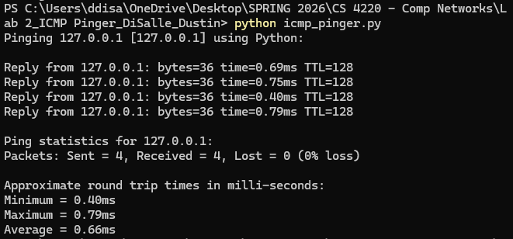
Google  (N. America) | 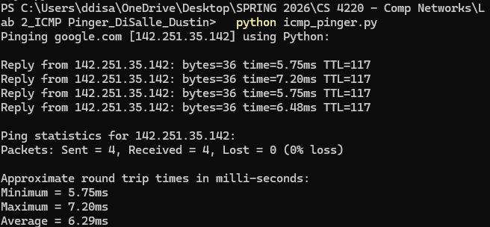
Cloudfare (1.1.1.1) | 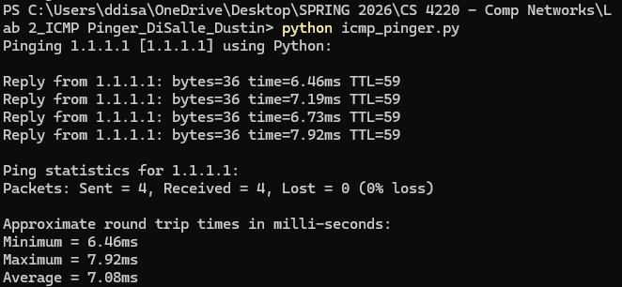
Europe | 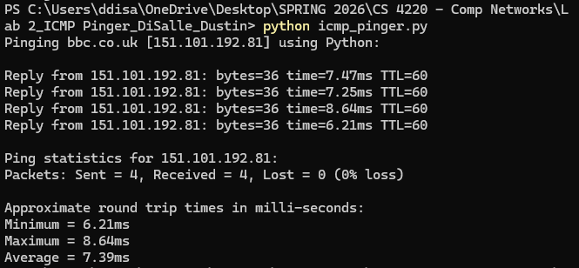
Asia | 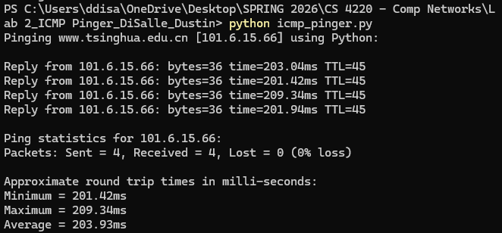
Africa | 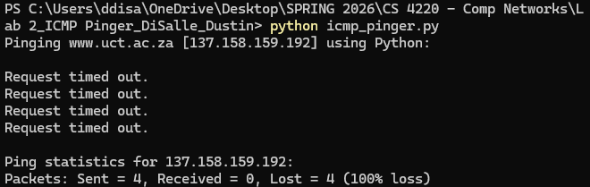

References
- Kurose, J. F., & Ross, K. W. (2021). Computer networking: A top-down approach (8th ed.). Pearson.
- OpenAI. (2026). ChatGPT (GPT-5.3) [Large language model]. https://chat.openai.com
  - Used to correct errors in code
  - Helped provide a shortened overall understanding of the lab assignment
- Postel, J. (1981). Internet Control Message Protocol (ICMP) (RFC 792). Internet Engineering Task Force. https://doi.org/10.17487/RFC0792
- Python Software Foundation. (2024). socket — Low-level networking interface. https://docs.python.org/3/library/socket.html
- Python Software Foundation. (2024). struct — Interpret bytes as packed binary data. https://docs.python.org/3/library/struct.html

